Dynamic Documents in Word

By Garret Christensen

Can you write a dynamic statistical document in MS Word? I think the answer is “kind of.” In my view, it feels a bit clunky, and it’s hard to see what the dynamically updated bits are and where they live. If you move files or change file names you’ll probably corrupt things and have to re-insert them. However, the ability to use tracked changes might make your life a lot easier, and the journal or publisher you want to submit to might just require Word.

# Run Code Separately

Let’s do it in conjunction with Stata. (You might be able to do the same thing in R with the stargazer package.) Run some code. The code below is in the makeoutput.do file.

sysuse auto

reg price mpg weight

estimates store autotest

esttab autotest using autotest.rtf

# Include a Table

Then insert that output table file autotest.rtf into Word. To do that, at least in Word 2010, click on Insert>>Object>>Create from File. Select the file autotest.rtf and make sure that “Link to File” is checked. The table should look something like what you see below. Note that this inserts the object kind of like an image—you can’t edit the text directly (but you can right click and edit the linked file).

Note that every time you open the paper file, you get the option of updating the links. Also, links seem to autoupdate (change and save the table file, then check if it automatically got updated in the paper file.)

# Include a Figure

You can also insert images and have them autoupdate, too. At least in Word 2010, Click Insert>>Picture and then when you find the file, don’t just click Insert, open the dropdown menu and click “Insert and Link.” See the screenshot below.

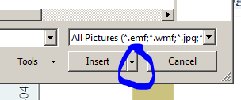

The figure below (pricehisto.png) should update automatically if you rerun the code.

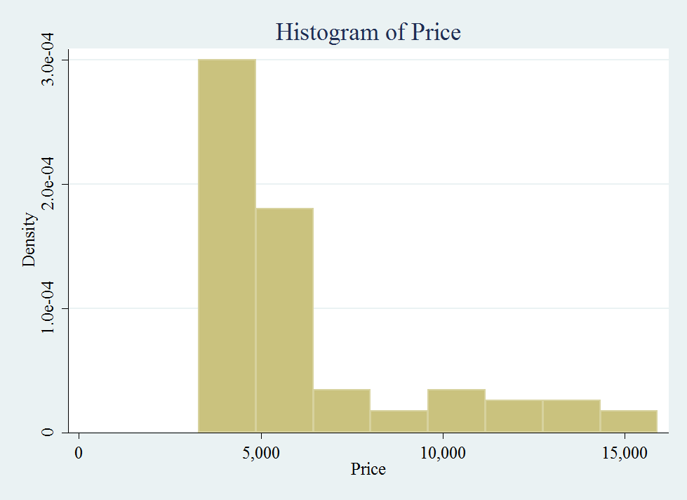

# Include a Word Doc

You can insert a Word doc into a Word doc, using the same Insert>>Object>>Create from File. So if you were writing a book, you could make every chapter a separate document. The “chapter” below is Woah-changed.docx.



## Include a Word Doc with Math or Dynamic Statistics using Markdoc

Since you can insert Word into Word, you could use Markdoc to put inline automatically calculated stats or LaTeX math directly into the Word doc, like the lines below. These are from example.docx which is generated when you run the Stata do file makeoutput.do.



You should also check out the [StatTag](http://sites.northwestern.edu/stattag/) project at Northwestern!